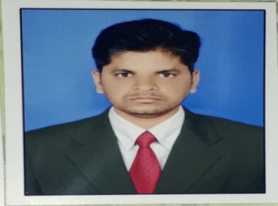
SANKARA REDDY.K
ANANTHAPUR
Mobile: 8317564571,9666829291
Email:kodamaganiksreddy@gmail.com
Objective:
To work in an organization, which could nurture my leadership qualities and where I get opportunities to grow and hence contribute to the development of the organization and self.
Educational Qualification:
EDUCATION | PASSING YEAR | SCHOOL/COLLEGE /UNIVERSITY | PERCENTAGE
DEGREE [Bsc] | 2009 | SK UNIVERISITY | 75
INTER | 2005 | GOVTJr.COLLEGE DHARMAVARAM | 69
SSC | 2003 | Govt high school JAGARAJUPALLI | 70
Strength:
Taking Initiative, Administration, Self Motivator, Quick learner.
Technical Skills:
Computer Proficiency: MS Word, Power Point, Excel, Internet E-Mails.
Experience:
1. Experience in DHANI FINIANCIAL SERVICES as a Personal loan collection manager 2017 jan to 2020 MARCH
2. BAJAJ FINANCE pvt ltd as collection manager NOVEMEMBER 2020 to MARCH 2022
Responsibilities...
Keep track of assigned accounts to identify outstanding debts.
Plan course of action to recover outstanding payments.
Locate and contact debtors to inquire of their payment status.
Negotiate payoff deadlines or payment plans.
Handle questions or complaints.
Investigate and resolve discrepancies.
Hobbies : Reading NEWS PAPERS and increasing knowledge related with my work.
Personal Details:
Name: K.SANKARA REDDY
Date of Birth:1june1989
Age: 30
Sex: MALE
Marital Status: SINGLE
Languages Known:TELUGU,ENGLISH,
PERNAMENT ADRESS
Name.Kanumukkala Shankara reddy
Village.Dupampalli
Mandal.Bukkapatnam
Distric.Ananthapur
DECLARATION :
The above furnished details true to the best of my knowledge and belief and credentials can be shown on demand. I hope you will pay kind attention to my case and will give me an opportunity to serve this prestigious industry.

Signature
ksreddy

